# Problem Statement:

Hooli Inc. is working on a product for which there is a distributed development team across geographies. Coordinating between the development team is proving to be difficult but the code needs to be synchronized. The company has chosen Git as the source repository for the product development. To check the functionality some sample math helper functions have been developed.

Check the Git integration with the help of the available code.

Functions:

•Addition

•Multiplication

•Calculation of sin/cos

•Distance between 2 points

Create these sample functions

Steps to Perform:

•Create user stories and task for the functionality and assign the sprints using Azure Board

•Assign the stories and tasks to the developer

•Change the status as per task execution

•Create a Git project holding the project

•Upload the project to Git

•Add new calculation functions to the project and check-in the changes to Git

•Compare the historical changes to see the changes introduced

•Creating a new local repository from the master repository for any new local repository.

Ans:

For Project IN VISUAL STUDIO I attach the solution file in zip format. PFA.

For Azure I attach screen shots here..

First I create a new project in Azure named Math-Helper

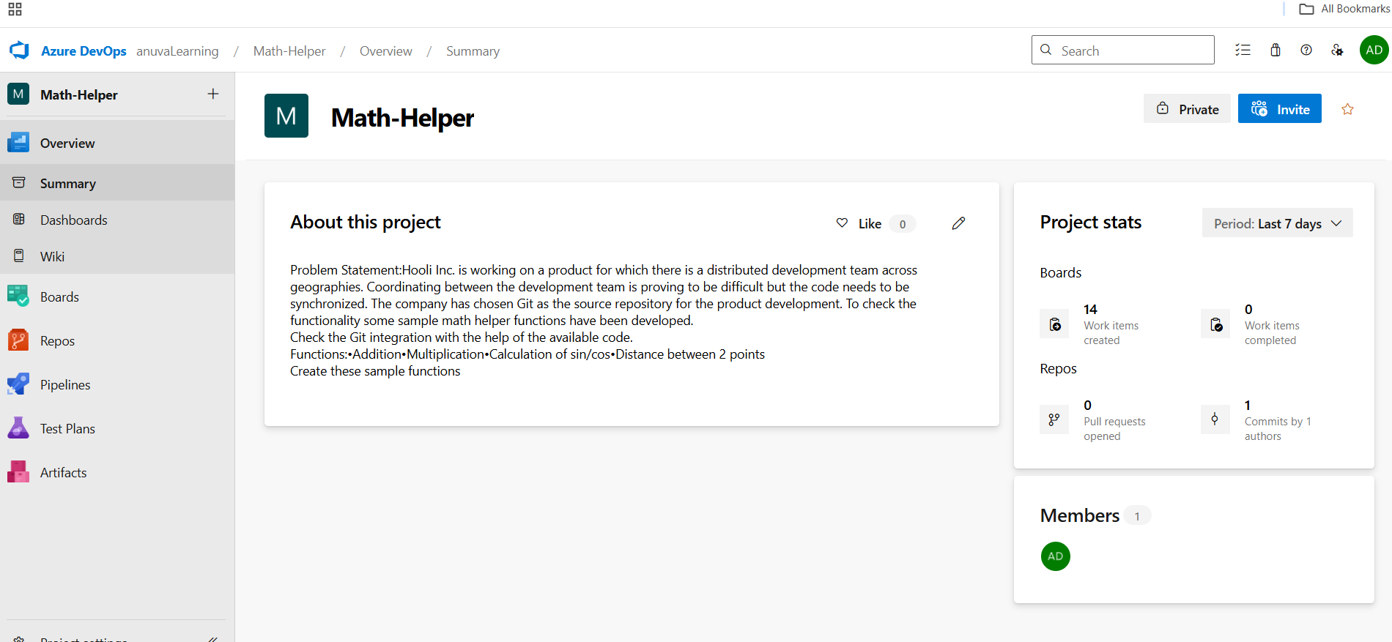

Then I add Epic , user stories and tasks.

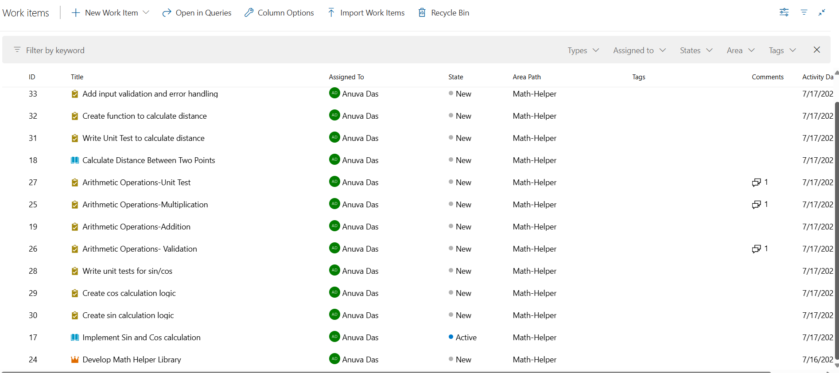

Here is the board with different status

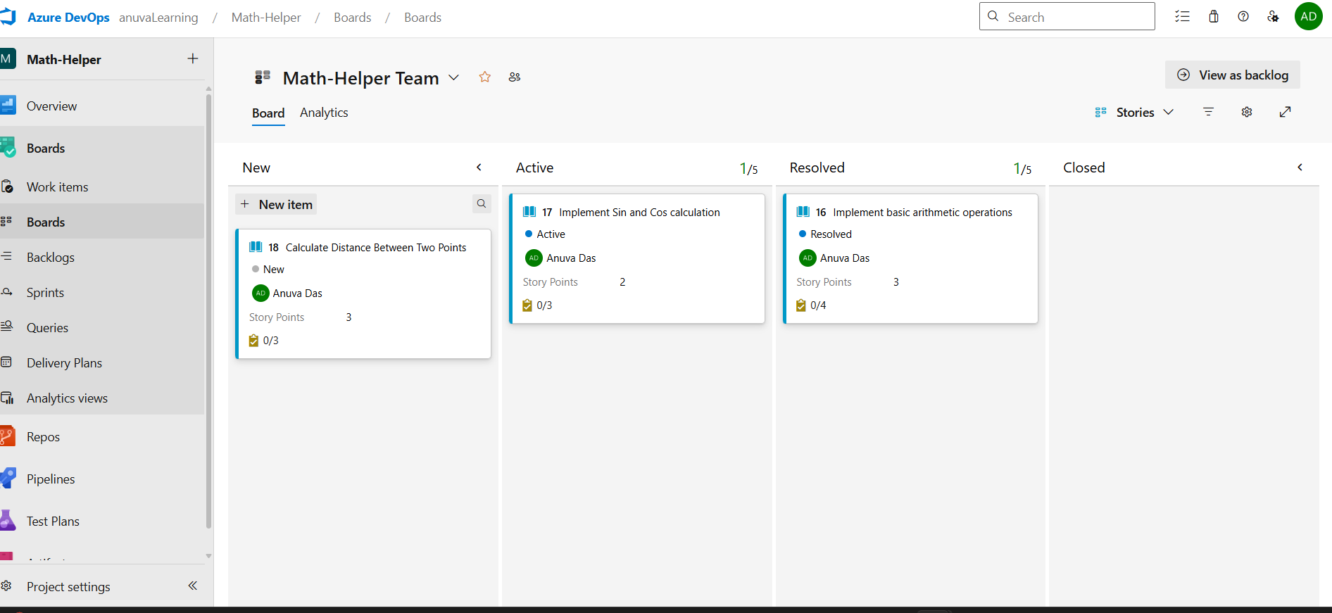

Change the status as per task execution

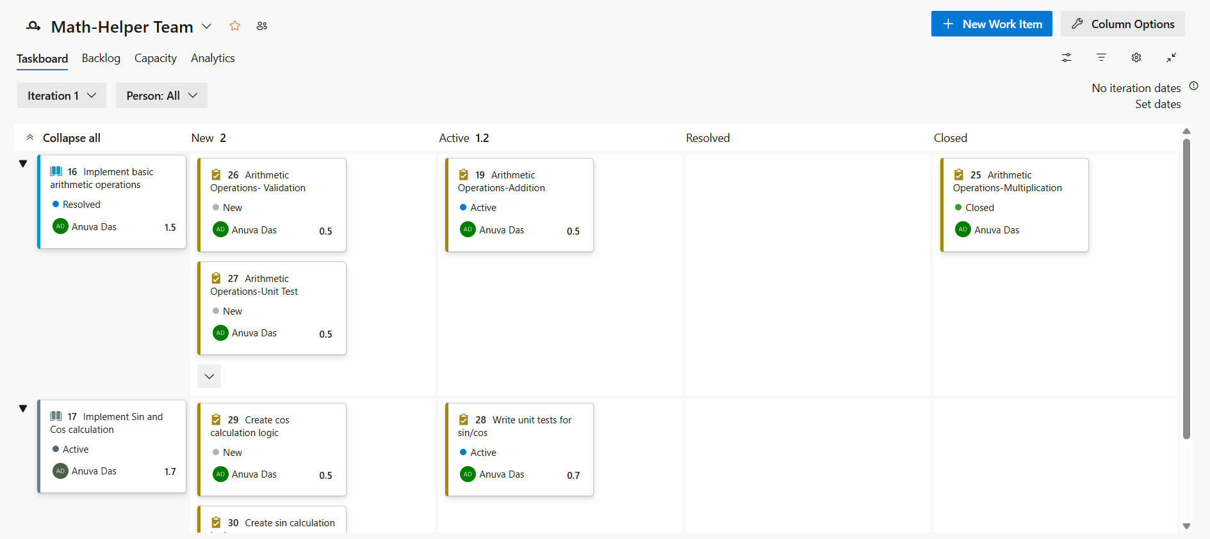

Upload the project to Git

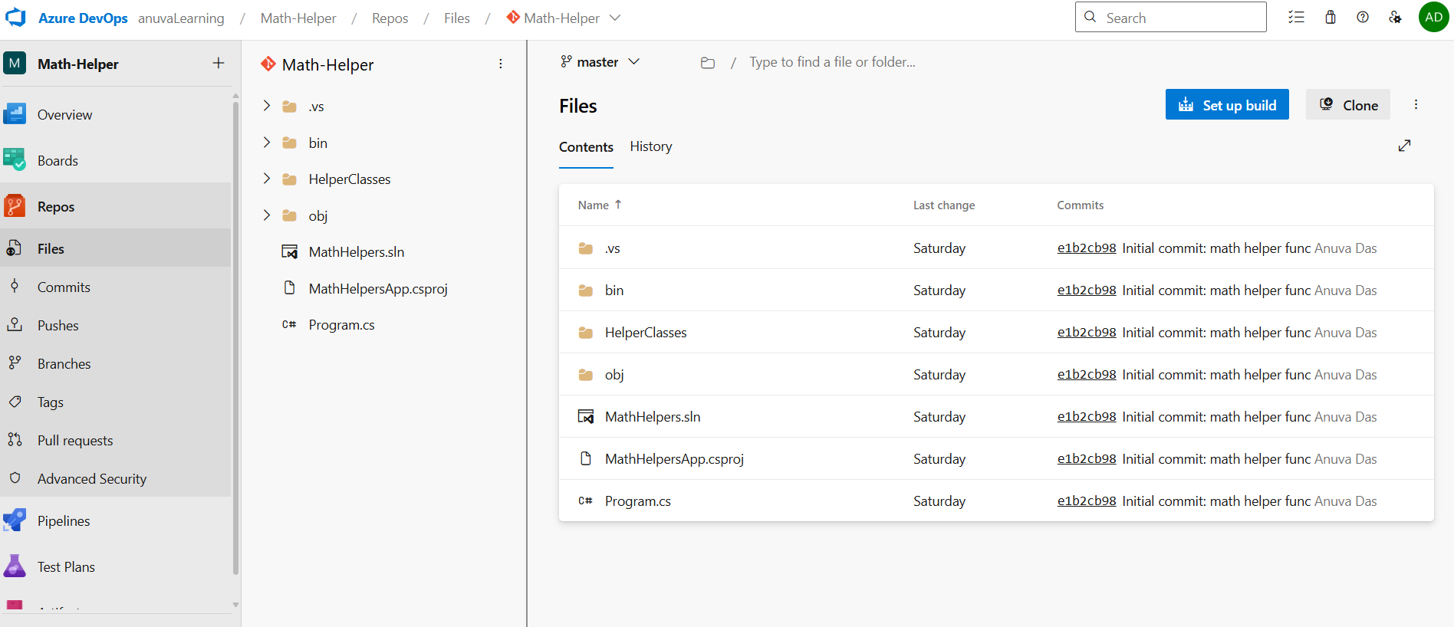

Add new calculation functions to the project and check-in the changes to Git

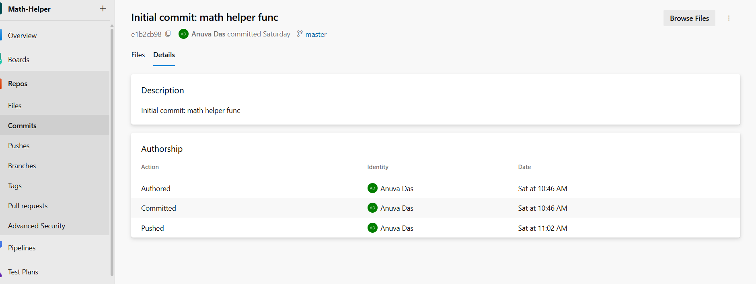

Compare the historical changes to see the changes introduced

